Supplementary Table 1 Chemical compounds
Compounds | Active? | Number | Structures
Engeletin | √ | 1 | 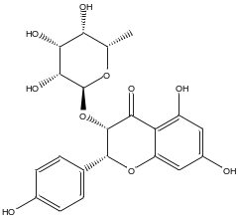
Isoengeletin | √ | 2 | 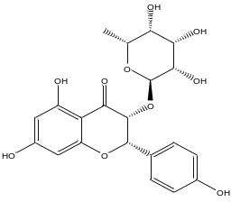
Astilbin | √ | 3 | 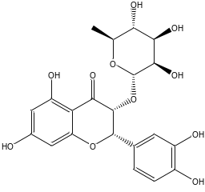
Polydatin | √ | 4 | 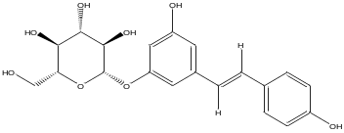
Resveratrol | √ | 5 | 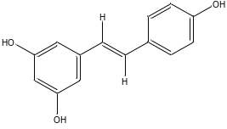
Kaempferol-7-O-β-D-glu (Populnin) |  | 6 | 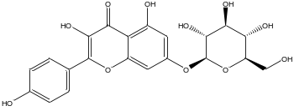
Quercetin-3-O-a-L-rhamnoside（Quercetin-3-rhamnoside） |  | 7 | 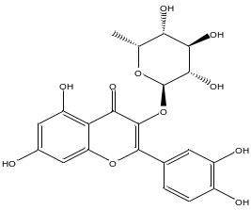
Sarsasapogenin | √ | 8 | 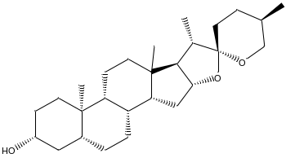
Dioscin |  | 9 | 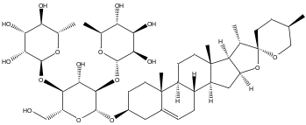
Rutin | √ | 10 | 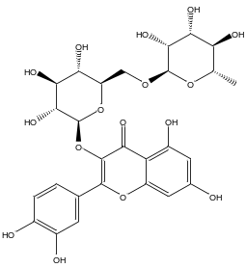
Kaemperol | √ | 11 | 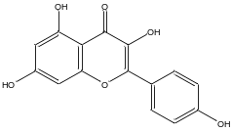
Dihydrokaempferol | √ | 12 | 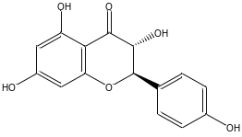
Kaempferol-5-O-β-D-glucoside |  | 13 | 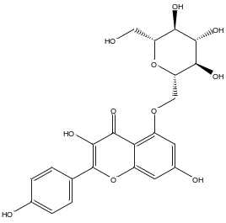
Quercetin-3'-O-glucoside |  | 14 | 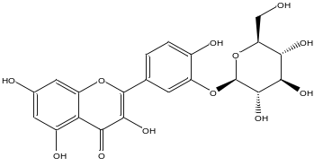
Taxifolin-3-O-glucoside |  | 15 | 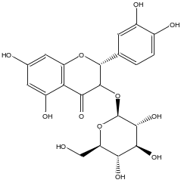
Quercetin-4'-O-β-D-glucoside |  | 16 | 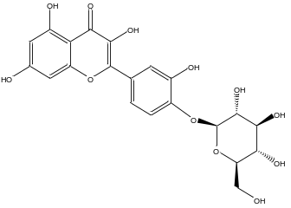
quercetin | √ | 17 | 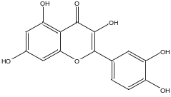
Isorhamnetin | √ | 18 | 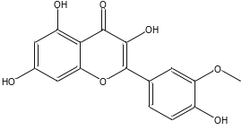
Dihydrokaempferol-5-O-β-D-glucoside |  | 19 | 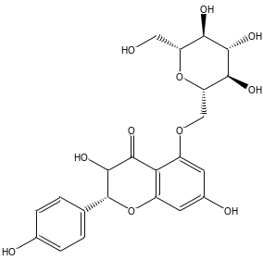
Dihydroquercetin-3-O-α-L-rhamnoside |  | 20 | 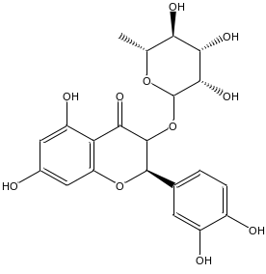
Piceatannol | √ | 21 | 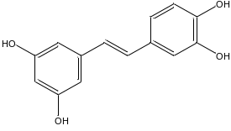
8-[(1R)-1-(3,4-dihydroxyphenyl)-3-methoxy-3-oxopropyl]-substituted catechin 101443796 |  | 22 | 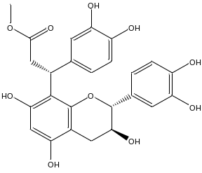
8-[(1R)-1-(3,4-dihydroxyphenyl)-3-methoxy-3-oxopropyl]-substituted 3-epicatechin 11755072 |  | 23 | 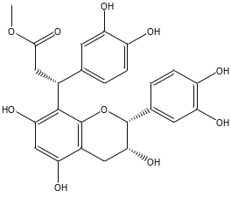
6-[(1S)-3-methoxy-3-oxo-1-(2,4,5-trihydroxyphe-nyl) propyl]- substituted catechin |  | 24 | 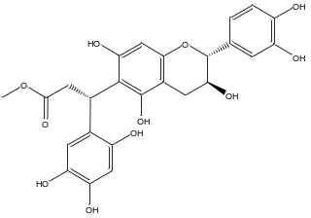
6-[(1R)-3-methoxy-3-oxo-1-(2,4,5-trihydroxyphe-nyl) propyl]-substituted catechin |  | 25 | 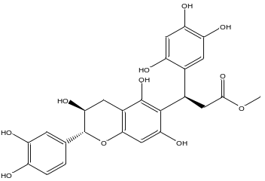
(2R,3R)-Dihydrokaempferol-3-O-(6"-oxy-acetyl)-β-D-glucoside |  | 26 | 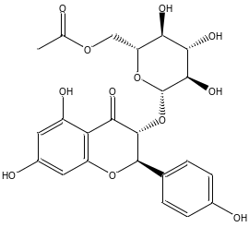
(2R,3R)-Dihydrokaempferol-3-O-(2"-oxy-acetyl)-β-D-glucoside |  | 27 | 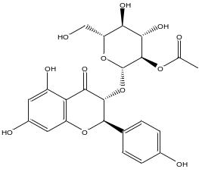
(2R,3R)-Dihydrokaempferol-3-O-(3"-oxy-acetyl)-β-D-glucoside |  | 28 | 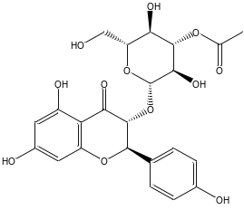
(2R,3R)-Dihydrokaempferol-3-O-β-D-glucoside |  | 29 | 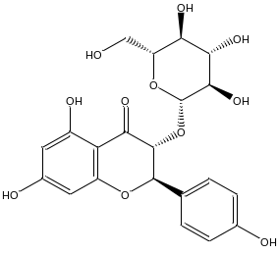
Oxyresveratrol | √ | 30 | 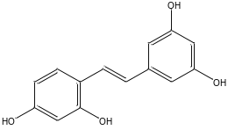
β-sitosterol |  | 31 | 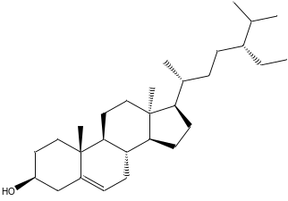
Daucosterol |  | 32 | 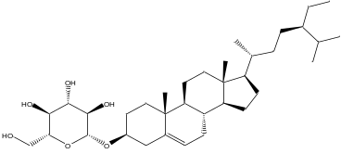
Saponin A |  | 33 | 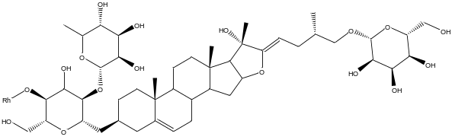
Saponin B |  | 34 | 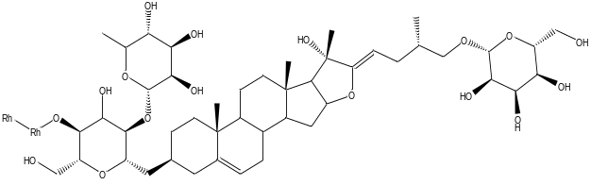
Saponin C |  | 35 | 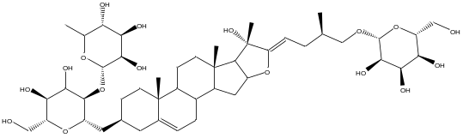
Saponin D |  | 36 | 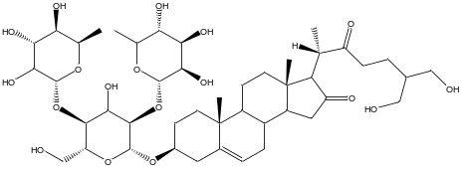
Butyl (Z)-3-(3,4-dihydroxyphenyl) prop-2-enoate |  | 37 | 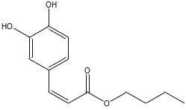
Butyl β-D-fructopyranoside | √ | 38 | 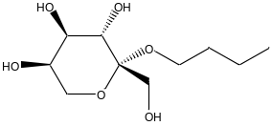
Syringic acid | √ | 39 | 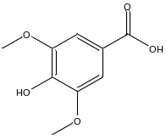
Protocatechuic acid | √ | 40 | 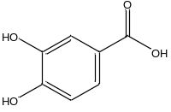
Vanillic acid | √ | 41 | 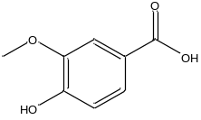
3,5-Dimethoxy-4-β-D-glucopyranosylcinnamic acid | √ | 42 | 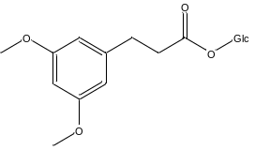
Maackoline | √ | 43 | 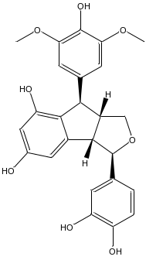
Moracin M | √ | 44 | 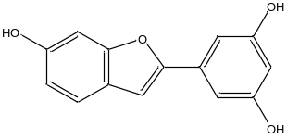
Gallic acid | √ | 45 | 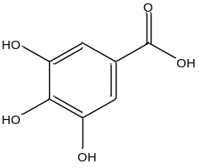
Trans-2-hydroxycinnamic acid | √ | 46 | 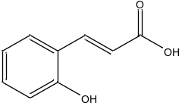
Gentisic acid | √ | 47 | 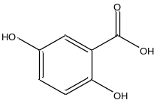
Dihydroquercetin | √ | 48 | 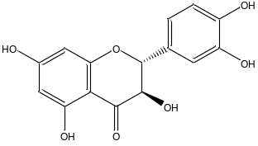
Dihydroquercetin-3'-O-glucoside |  | 49 | 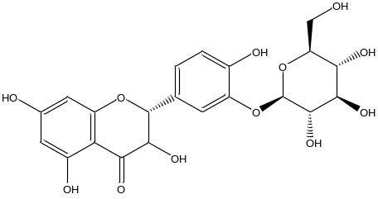
Oleanolic acid | √ | 50 | 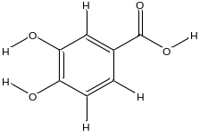
Caffeic acid | √ | 51 | 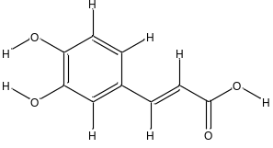
Ergosterol |  | 52 | 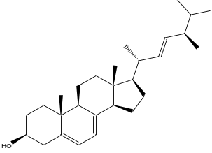
Methylprotodioscin_qt |  | 53 | 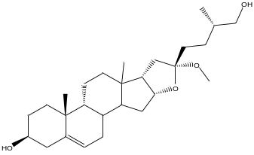
Pseudodiosgenin |  | 54 | 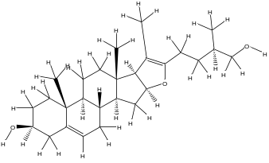
Coumarin | √ | 55 | 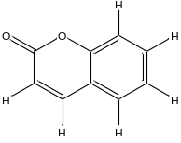
Methylprotodioscin |  | 56 | 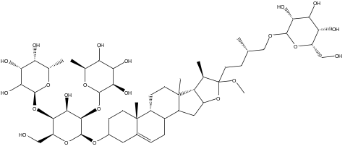
Methylprotogracillin |  | 57 | 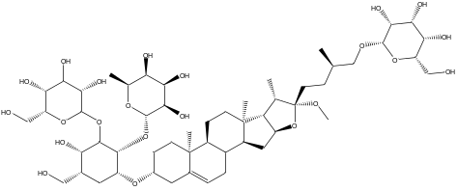
Kaempferide | √ | 58 | 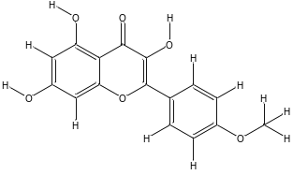
Pseudoprotodioscin |  | 59 | 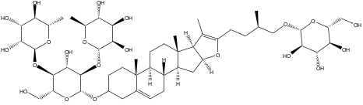
Gramine | √ | 60 | 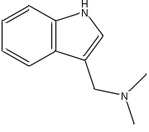
Scirpusin A |  | 61 | 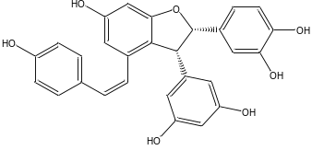
Dihydrokaempferide |  | 62 | 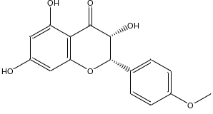
Diosgenin |  | 63 | 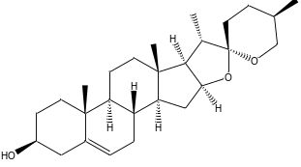
Palmitic acid |  | 64 | 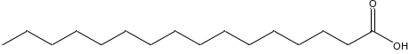
Chlorogenic acid |  | 65 | 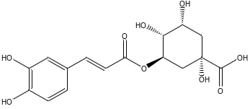
Parillin |  | 66 | 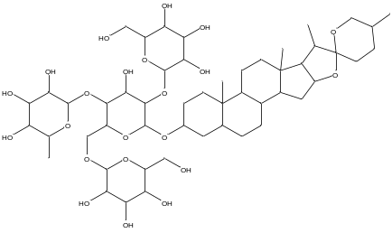
S. aristolochiaefolia mill |  | 67 | 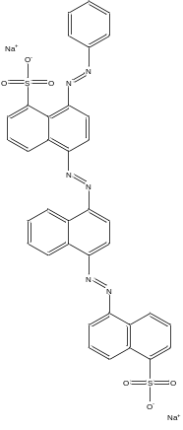
Smilaxin |  | 68 | 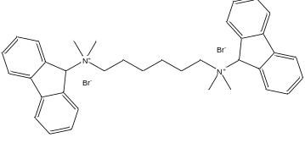

Supplementary Table 2 7 Annotation clustering huddles
Functional annotation clustering | KEGG pathways
Nervous system | hsa04932:Non-alcoholic fatty liver disease (NAFLD)
Nervous system | hsa05010:Alzheimer's disease
Nervous system | hsa05012:Parkinson's disease
Nervous system | hsa00190:Oxidative phosphorylation
Nervous system | hsa05016:Huntington's disease
Comprehensive regulation | hsa04066:HIF-1 signaling pathway
Comprehensive regulation | hsa04931:Insulin resistance
Comprehensive regulation | hsa05205:Proteoglycans in cancer
Comprehensive regulation | hsa04917:Prolactin signaling pathway
Comprehensive regulation | hsa04370:VEGF signaling pathway
Comprehensive regulation | hsa05215:Prostate cancer
Comprehensive regulation | hsa05223:Non-small cell lung cancer
Comprehensive regulation | hsa04071:Sphingolipid signaling pathway
Comprehensive regulation | hsa05230:Central carbon metabolism in cancer
Comprehensive regulation | hsa04012:ErbB signaling pathway
Comprehensive regulation | hsa05161:Hepatitis B
Comprehensive regulation | hsa05214:Glioma
Comprehensive regulation | hsa04722:Neurotrophin signaling pathway
Comprehensive regulation | hsa04919:Thyroid hormone signaling pathway
Comprehensive regulation | hsa05221:Acute myeloid leukemia
Comprehensive regulation | hsa04664:Fc epsilon RI signaling pathway
Comprehensive regulation | hsa04660:T cell receptor signaling pathway
Comprehensive regulation | hsa04068:FoxO signaling pathway
Comprehensive regulation | hsa04014:Ras signaling pathway
Comprehensive regulation | hsa04668:TNF signaling pathway
Comprehensive regulation | hsa05212:Pancreatic cancer
Comprehensive regulation | hsa05218:Melanoma
Comprehensive regulation | hsa05220:Chronic myeloid leukemia
Comprehensive regulation | hsa04725:Cholinergic synapse
Comprehensive regulation | hsa04915:Estrogen signaling pathway
Comprehensive regulation | hsa04015:Rap1 signaling pathway
Comprehensive regulation | hsa04914:Progesterone-mediated oocyte maturation
Comprehensive regulation | hsa05169:Epstein-Barr virus infection
Comprehensive regulation | hsa04151:PI3K-Akt signaling pathway
Comprehensive regulation | hsa05211:Renal cell carcinoma
Comprehensive regulation | hsa05231:Choline metabolism in cancer
Comprehensive regulation | hsa05210:Colorectal cancer
Comprehensive regulation | hsa04662:B cell receptor signaling pathway
Comprehensive regulation | hsa04380:Osteoclast differentiation
Comprehensive regulation | hsa05213:Endometrial cancer
Comprehensive regulation | hsa05142:Chagas disease (American trypanosomiasis)
Comprehensive regulation | hsa05160:Hepatitis C
Comprehensive regulation | hsa05222:Small cell lung cancer
Comprehensive regulation | hsa04062:Chemokine signaling pathway
Comprehensive regulation | hsa04620:Toll-like receptor signaling pathway
Comprehensive regulation | hsa04210:Apoptosis
Comprehensive regulation | hsa04510:Focal adhesion
Comprehensive regulation | hsa04150:mTOR signaling pathway
Comprehensive regulation | hsa05152:Tuberculosis
Comprehensive regulation | hsa04910:Insulin signaling pathway
Comprehensive regulation | hsa04611:Platelet activation
Comprehensive regulation | hsa04930:Type II diabetes mellitus
Comprehensive regulation | hsa05145:Toxoplasmosis
Comprehensive regulation | hsa05166:HTLV-I infection
Comprehensive regulation | hsa05164:Influenza A
Comprehensive regulation | hsa05120:Epithelial cell signaling in Helicobacter pylori infection
Comprehensive regulation | hsa04550:Signaling pathways regulating pluripotency of stem cells
Comprehensive regulation | hsa04960:Aldosterone-regulated sodium reabsorption
Comprehensive regulation | hsa04666:Fc gamma R-mediated phagocytosis
Comprehensive regulation | hsa05133:Pertussis
Comprehensive regulation | hsa04650:Natural killer cell mediated cytotoxicity
Comprehensive regulation | hsa04621:NOD-like receptor signaling pathway
Comprehensive regulation | hsa05140:Leishmaniasis
Comprehensive regulation | hsa05132:Salmonella infection
Comprehensive regulation | hsa05146:Amoebiasis
Comprehensive regulation | hsa05131:Shigellosis
Comprehensive regulation | hsa04622:RIG-I-like receptor signaling pathway
Comprehensive regulation | hsa04810:Regulation of actin cytoskeleton
Comprehensive regulation | hsa04070:Phosphatidylinositol signaling system
Hormone production and release | hsa04912:GnRH signaling pathway
Hormone production and release | hsa04921:Oxytocin signaling pathway
Hormone production and release | hsa04916:Melanogenesis
Metabolism | hsa05204:Chemical carcinogenesis
Metabolism | hsa00980:Metabolism of xenobiotics by cytochrome P450
Metabolism | hsa00982:Drug metabolism - cytochrome P450
Acid and lipid metabolism | hsa00591:Linoleic acid metabolism
Acid and lipid metabolism | hsa00590:Arachidonic acid metabolism
Acid and lipid metabolism | hsa00592:alpha-Linolenic acid metabolism
Acid and lipid metabolism | hsa00565:Ether lipid metabolism
Acid and lipid metabolism | hsa04975:Fat digestion and absorption
Acid and lipid metabolism | hsa00564:Glycerophospholipid metabolism
Nervous and humoral regulation | hsa04713:Circadian entrainment
Nervous and humoral regulation | hsa04916:Melanogenesis
Nervous and humoral regulation | hsa04925:Aldosterone synthesis and secretion
Nervous and humoral regulation | hsa04911:Insulin secretion
Nervous and humoral regulation | hsa04971:Gastric acid secretion
Nervous and humoral regulation | hsa04740:Olfactory transduction
Immunoregulation | hsa04670:Leukocyte transendothelial migration
Immunoregulation | hsa05100:Bacterial invasion of epithelial cells
Immunoregulation | hsa04070:Phosphatidylinositol signaling system
Infection | hsa04918:Thyroid hormone synthesis
Infection | hsa05110:Vibrio cholerae infection
Infection | hsa04970:Salivary secretion

Supplementary Table 2 Glide gscore score of active compounds docking with PID targets.
Title | Compounds | MPO  (PDB ID: 5fiw) | LCN2  (PDB ID: 1x89) | PTGS2  (PDB ID: 5f19) | STAT3  (PDB ID: 5ax3) | TNF  (PDB ID: 2az5) | MMP9  (PDB ID: 5ue4)
 | Contrast | -6.687 | -7.190 | -10.182 | -8.713 | -7.971 | -8.661
1 | Engeletin | -6.151 | -6.218 | -8.095 | -8.342 | -6.132 | -4.672
2 | Isoengeletin | -6.736 | -4.969 | -8.168 | -7.195 | -6.970 | -5.218
3 | Astilbin | -6.349 | -4.625 | -6.839 | -7.839 | -6.123 | -4.961
4 | Polydatin | -5.931 | -5.628 | -9.365 | -8.846 | -7.373 | -8.988
5 | Resveratrol | -7.252 | -5.722 | -7.766 | -8.195 | -7.042 | -8.695
8 | Sarsasapogenin | -4.168 | -4.019 | -4.320 | -3.534 | -5.165 | -3.67
10 | Rutin | -7.919 | -7.320 | -10.758 | -7.896 | -7.569 | -5.962
11 | Kaempferol | -6.586 | -6.353 | -7.827 | -7.143 | -6.450 | -7.734
12 | Dihydrokaempferol | -6.017 | -4.463 | -6.743 | -8.167 | -7.168 | -6.428
17 | Quercetin | -6.168 | -6.353 | -7.537 | -8.367 | -6.869 | -7.888
18 | Isorhamnetin | -5.236 | -6.347 | -8.274 | -7.995 | -6.322 | -7.644
21 | Piceatannol | -5.531 | -4.855 | -9.223 | -8.673 | -6.821 | -8.038
30 | Oxyresveratrol | -8.098 | -5.782 | -8.763 | -8.085 | -6.718 | -9.241
38 | Butyl β-D-fructopyranoside | -4.82 | -4.714 | -5.210 | -5.094 | -4.934 | -4.992
39 | Syringic acid | -4.957 | -4.879 | -5.896 | -6.472 | -5.492 | -6.392
40 | Protocatechuic acid | -5.497 | -4.529 | -6.122 | -5.586 | -5.533 | -6.018
41 | Vanillic acid | -5.083 | -4.666 | -6.342 | -6.145 | -5.342 | -6.139
42 | 3,5-Dimethoxy-4-β-D-glucopyranosylcinnamic acid | -4.991 | -4.530 | -7.018 | -3.835 | -6.804 | -6.554
43 | Maackoline | -5.753 | -4.833 | -8.503 | -6.179 | -6.603 | -3.502
44 | Moracin M | -6.693 | -4.260 | -7.675 | -9.326 | -6.883 | -7.923
45 | Gallic acid | -5.174 | -4.566 | -6.069 | -5.929 | -5.354 | -6.112
46 | Trans-2-hydroxycinnamic acid | -5.976 | -4.118 | -6.357 | -6.525 | -5.601 | -6.473
47 | Gentisic acid | -5.372 | -5.825 | -6.812 | -6.741 | -5.647 | -6.199
48 | Dihydroquercetin | -6.81 | -4.637 | -7.856 | -8.469 | -6.874 | -6.411
50 | Oleanolic acid | -5.506 | -4.494 | -6.133 | -5.810 | -5.539 | -6.018
51 | Caffeic acid | -5.325 | -4.685 | -6.087 | -5.659 | -5.757 | -6.541
53 | Methylprotodioscin_qt | -5.169 | -4.007 | -6.746 | -6.194 | -5.084 | -6.196
55 | Coumarin | -5.679 | -5.246 | -6.527 | -5.716 | -5.922 | -4.762
58 | Kaempferide | -5.601 | -4.703 | -8.184 | -7.133 | -6.673 | -7.962
60 | Gramine | -5.105 | -4.507 | -6.838 | -6.100 | -7.419 | -6.629
62 | Dihydrokaempferide | -5.717 | -4.744 | -8.275 | -6.505 | -6.550 | -6.282
63 | Diosgenin | -4.684 | -3.875 | -6.480 | -4.983 | -6.180 | -5.518

Supplementary Fig. 1. IL-17 signaling pathway

